Core Java

Software Requirement

* JDK 17 or later
* Eclipse IDE / VS Code

How to verify java installation

Two commands

1. javac
2. java

Java: It is a Platform Independent & Object oriented programming language

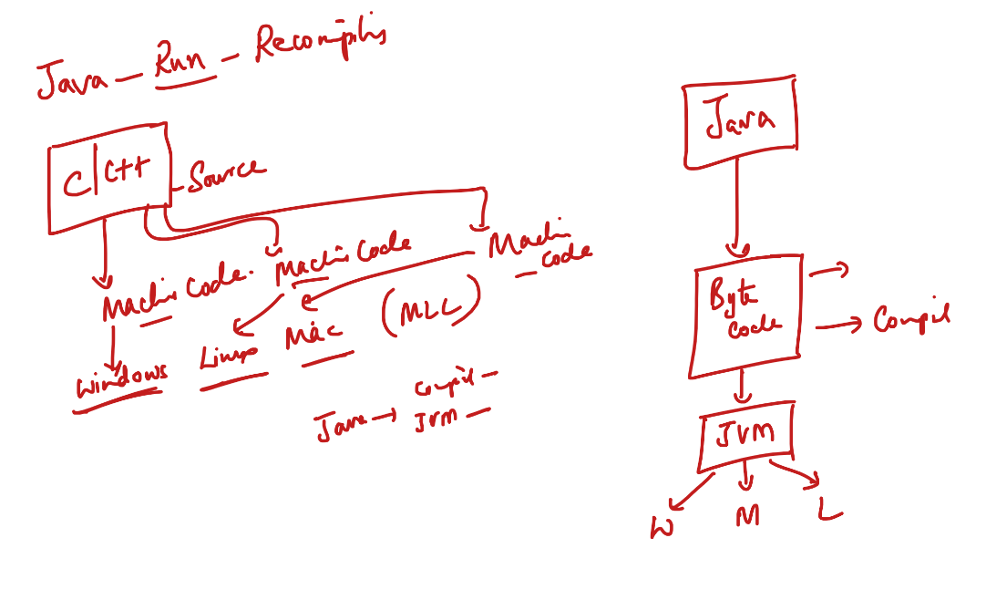

Object Oriented Programming Language

It helps programmers to create real world entities in the application and make these real world entities to interact with another real world entities to complete any task.

Building blocks of any object oriented programming language

1. class: Blueprint of an object, that represents object structure
2. object: It is an instance of a class / real world entity that you can create from the class

Terms in Java

1. JDK: Java Development Kit – software that gives compiler and JRE both
2. JRE: Java Runtime Environment – place where your java application runs, it will have JVM and other components to load the application
3. JVM: Java Virtual Machine – an interpreter to convert byte code to machine code

Java versions: Java 8, Java 11, Java 17, Java 21

Java Editions:

1. JSE: Java Standard Edition – where you can create java programs in console based application
2. JEE : Java Enterprise Edition – where you can create java programs in web based applications

How to write our first java program

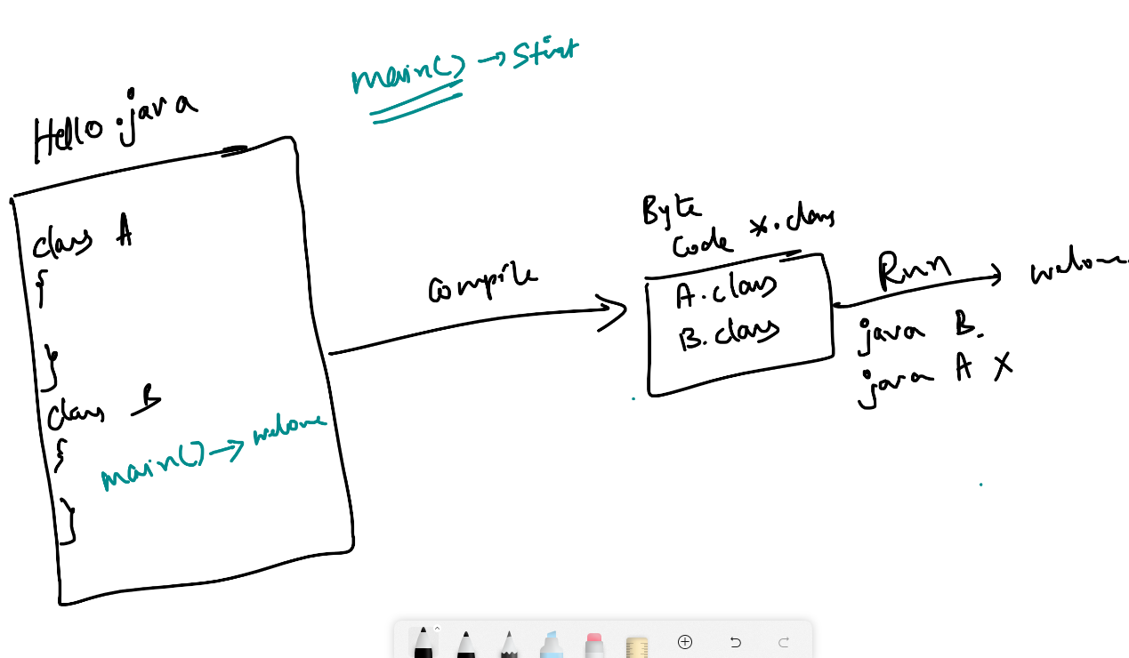

Fundamentals

1. Datatypes
2. Operators
3. Conditional Statements
4. Loops
5. Arrays
6. Classes & Objects

Datatypes: These are keywords used to create variables that specifies what kind of value it stores

int x = 20;

double y = 55.4;

Java has following datatypes & each datatypes has fixed size

|  |  |  |
| --- | --- | --- |
| Datatype | Size in bytes | Range |
| byte | 1 | -128 to +127, including 0 |
| short | 2 | -32768 to +32767, with 0 |
| int | 4 |  |
| long | 8 |  |
| float | 4 |  |
| double | 8 |  |
| char | 2 |  |
| boolean | 1 |  |

TestDatatypes.java

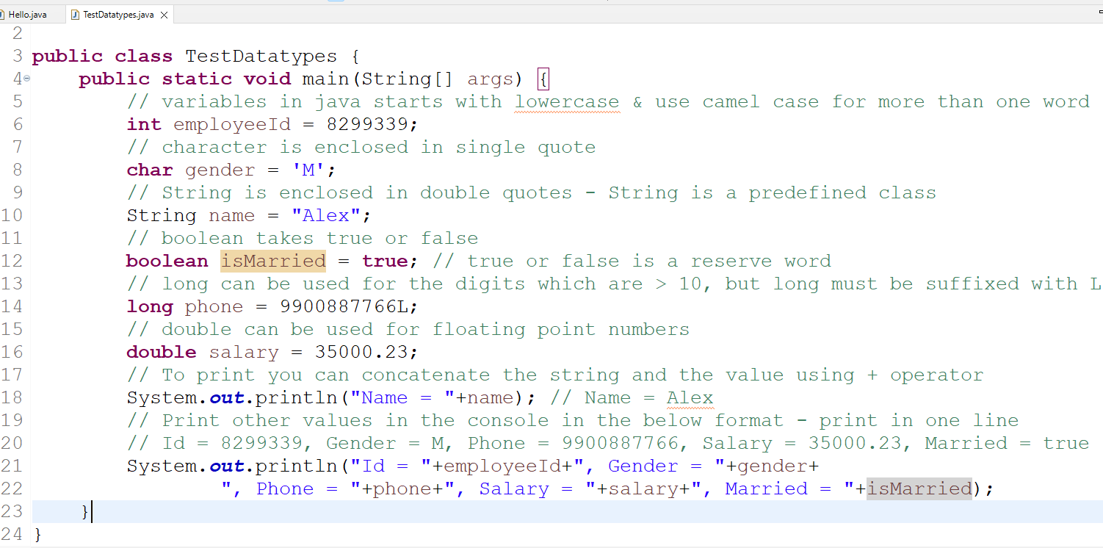

Output:

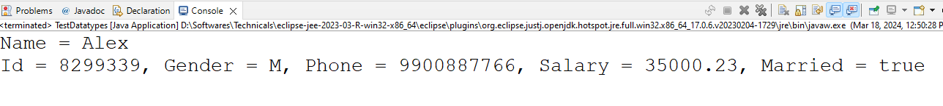

Same program which takes input from the keyboard, instead of hard coding the values

In Java we have an inbuilt class Scanner in java.util package, we must import this

import java.util.Scanner;

Then we must create a Scanner object to take input from the keyboard

Scanner scan = new Scanner(System.in);

You must call inbuilt methods of Scanner to take different types of value

int x = scan.nextInt(); // to read int value  
double y = scan.nextDouble(); // to read double value  
String z = scan.next(); // to read a single string word  
boolean b = scan.nextBoolean(); // to read a boolean  
long l = scan.nextLong(); // to read a long

To read character you don’t have a method in scanner, you must use String and call the charAt(index) method to get a character of a specific string value

char ch = “Hello”.charAt(1); // ch = e

String z = scan.next();  
char ch = z.charAt(0); // very first character

char ch = scan.next().charAt(0); // ch = very first character of the string

TestDatatypes.java

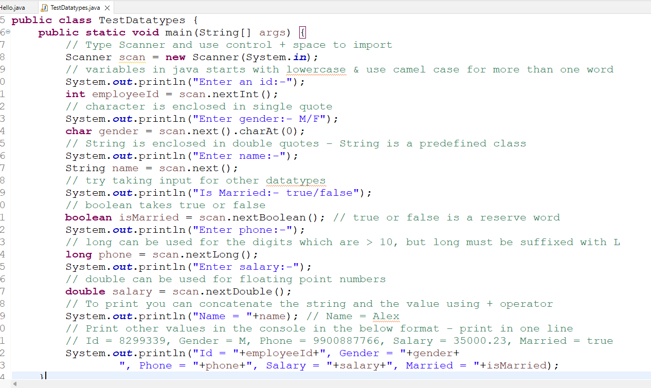

Operators:

=, +, -, *, /, <, >, <=, >=, ==, ++, --

x = 5;

y = x++; // post increment

Conditional Statements

if

if else

if else if else if else

switch

TestConditions.java

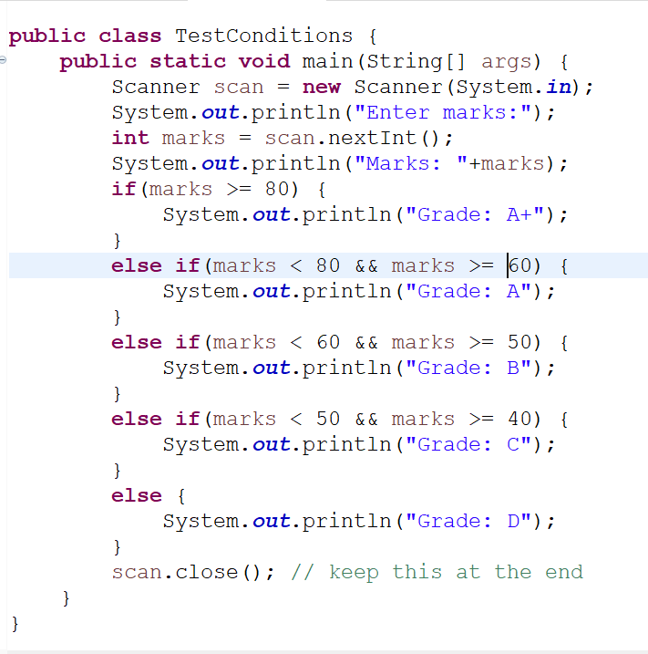

TestConditions.java with switch

switch(options) {  
 case optionValue: statements;  
 break;  
 case optionValue: statements;  
 break;  
 default : statements  
}

Here optionValues can be int, String, char  
case 1 or case “someString” or case ‘A’

Loops

1. for
2. while
3. do while

for loop: When you know how many times you want to iterate

while & do while: When you don’t know how many times you want to iterate but you want to iterate until some condition true

while: first condition is checked & then executed, its like checking the condition in the beginning

do while: At least once the statement executed and then the condition is checked, its like checking the condition while exiting

TestLoops.java

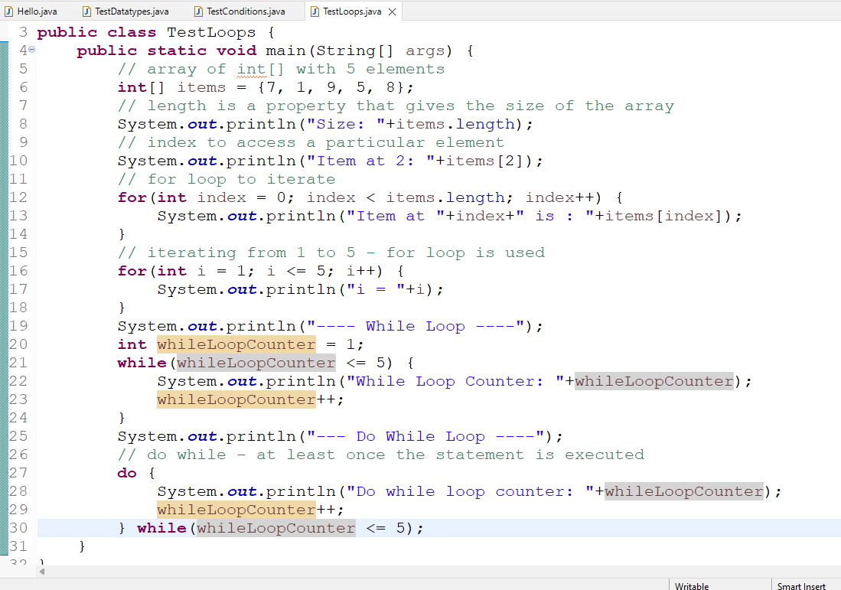

Activity:

1. Create an array of numbers and print the maximum and minimum value in the array & the sum of all the elements in the array using only one for loop

ex: items = {7, 1, -7, 8, 9, 3}, Max = 9, Min = -7, Sum = 21

1. Enter a 3 digit number and print each digit in words

ex: Input = 762, Output = Seven, Six, Two

1. Enter a 3 digit number & add the highest and lowest digit of the 3 digits

ex: Input = 762, Output = 7 + 2 = 9

Classes & Objects

class can have three things mainly

1. variables/fields/properties: Stores data
2. methods/functions: Performs action, it will have logics
3. constructors: Its like a methods but its sole job is to initialize the properties

Employee.java

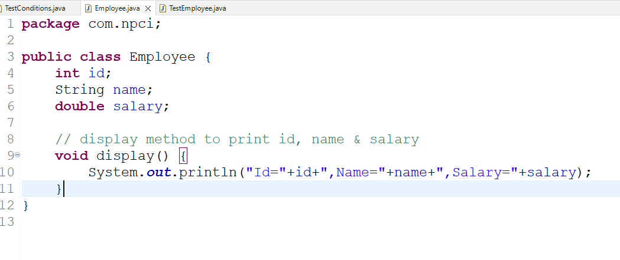

TestEmployee.java

